Lab 5: LAN Configuration

Objectives
- Create a LAN.
- Use all the knowledge learned from previous labs.

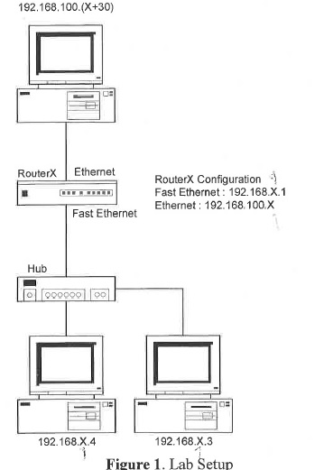

Part 1: Set up your physical connections.

Step 1. Locate a router, a switch, and three computers

Step 2. Connect each of these devices according to Figure 1.
Make sure that the computer connected to the router has both a console cable and an ethernet cable.

Step 3. Configure the IP addresses

Computer | IP Address | Subnet Mask | Default gateway
Computer 1 (connected to router) | 192.168.100.31 | 255.255.255.0 | 192.168.100.1
Computer 2 | 192.168.1.4 | 255.255.255.0 | 192.168.1.1
Computer 3 | 192.168.1.3 | 255.255.255.0 | 192.168.1.1

Part 2: Configuring the Router using Tera Term

Step 1. Launch Tera Term

Step 2. Configure the interfaces
- Determine the interfaces being used in this network
Q: Which interfaces are being used
Ethernet0, fast Ethernet 0, serial 0, serial 1
- View the interfaces by typing: show interface
- Enter the Global Configuration Mode (“configure terminal”)
- Configure each specific interface by using the command: interface [interface name]
- Assign an IP address to each interface by using the command: ip address [default gateway] [subnet mask]
- Make sure the interface is online by using the command: no shutdown
Do these steps for each of the interfaces in use.
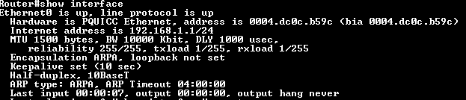
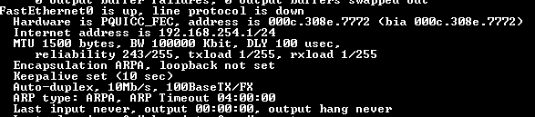
Fast Ethernet is on 192.168.254.1
Ethernet is on 192.168.1.1

Part 3: Testing the Network
In this part we will be testing the network by using the ping and tracert commands.

Step 1. From Computer 1 to Computer 2
- Ping
- Tracert
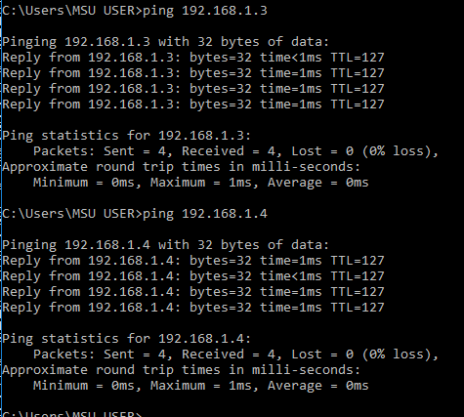
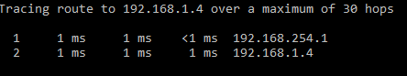
Q: What are the results?

Step 2. From Computer 2 to Computer 3
- Ping
- Tracert

Q: What are the results?

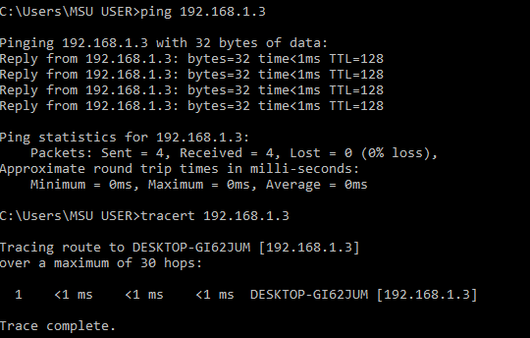

Step 3. From Computer 3 to Computer 1
- Ping
- Tracert

Q: What are the results?

